SDR Sharp Lab

* **Description:**
  + This lab will explore the software SDR Sharp from AIRSPY (<https://airspy.com/>). SDR Sharp is a wildly used tool for SDR work. It allows for quick and easy exploration of the radio spectrum range your SDR can observe. It also has a large community of developers that make plug in’s that extend the functionality of SDR Sharp. In this lab we will listen to a FM radio station, observe 433MHz devices, and listen to NOAA weather broadcasts (USA only)
* **Objectives:**
  + Download and install SDR Sharp, 433MHz plug in
  + Load the 433MHz plug in into SDR Sharp
  + Explore SDR Sharp
  + Listen to FM broadcasts
  + Listen to 433MHz devices
  + Listen to NOAA weather radio
* **Materials:**
  + The frequency of a Radio station in the area the lab will be held at. (i.e. 92.9)
  + Windows computer with at least 8 CPU cores, 8 GB of ram, and 11 GB of storage
  + Nooelec NESDR mini + antenna
  + Internet connection or USB containing the following files
    - https://airspy.com/?ddownload=3130
    - https://github.com/marco402/plugin-Rtl433-for-SdrSharp/archive/refs/heads/master.zip

**Setup:**

We first need to install SDR Sharp and the 433HMz plug in.

1. Plug in you Nooelec NESDR mini + antenna to the computer.
2. Download SDR Sharp and the 433MHz plug in from the links in the Materials section
3. Extract the files “sdrsharp-x86.zip” and “plugin-Rtl433-for-SdrSharp-master.zip”
4. In the folder that was extracted from “sdrsharp-x86.zip”, there should be a file named “install-rtlsdr.bat”. We need to run this file by double clicking it. This will install the needed driver for SDR Sharp to talk to our SDR. A popup window should open and begain to download the needed drivers. Once it says “Press any key to continue . . .”,it is done installing and e can y press or click on the X in the top right of that window will close the prompt.

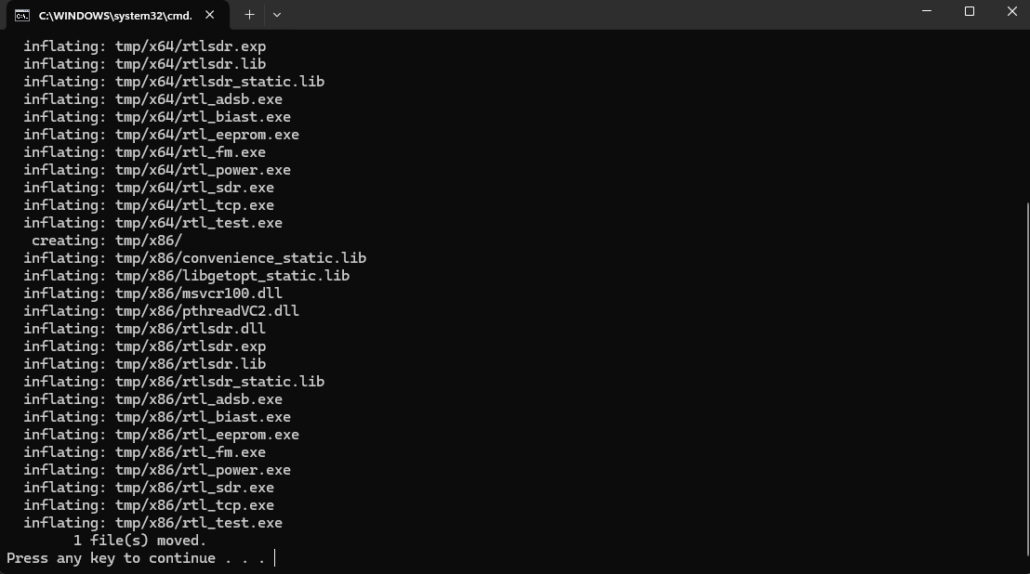

1. Launch the executable called SDRSharp.exe. A window similar to the image bellow should open. If it does then that mean the program was successfully installed.

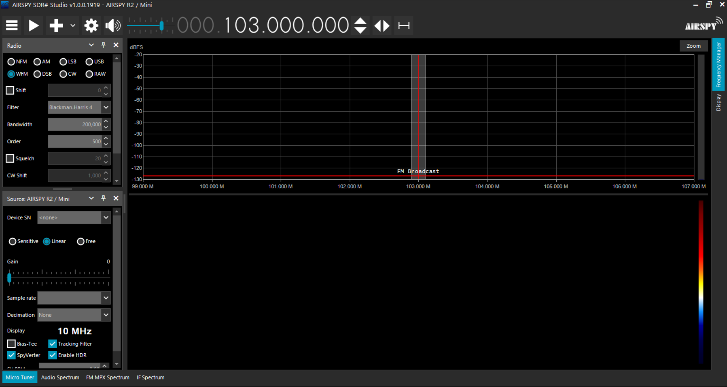

1. Now we need to install the 433MHz plug in. To do this close out of SDR Sharp. Then navigate to the folder you extracted from “plugin-Rtl433-for-SdrSharp-master.zip”. Look in plugin-Rtl433-for-SdrSharp-master → install → 1.5.6.2. There should be 3 files that end in .dll.

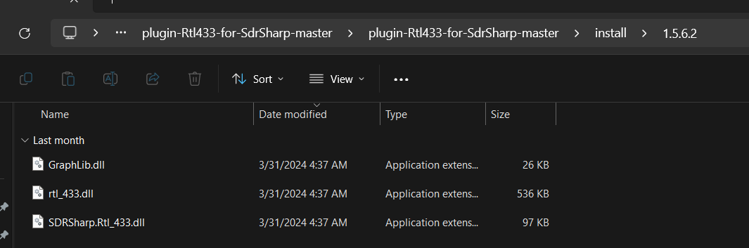

1. Copy all 3 of the files above and navigate back the SR Sharp folder. In the “sdrsharp-x86” there should be a folder named “Plugins”. This can be seen in the image bellow.

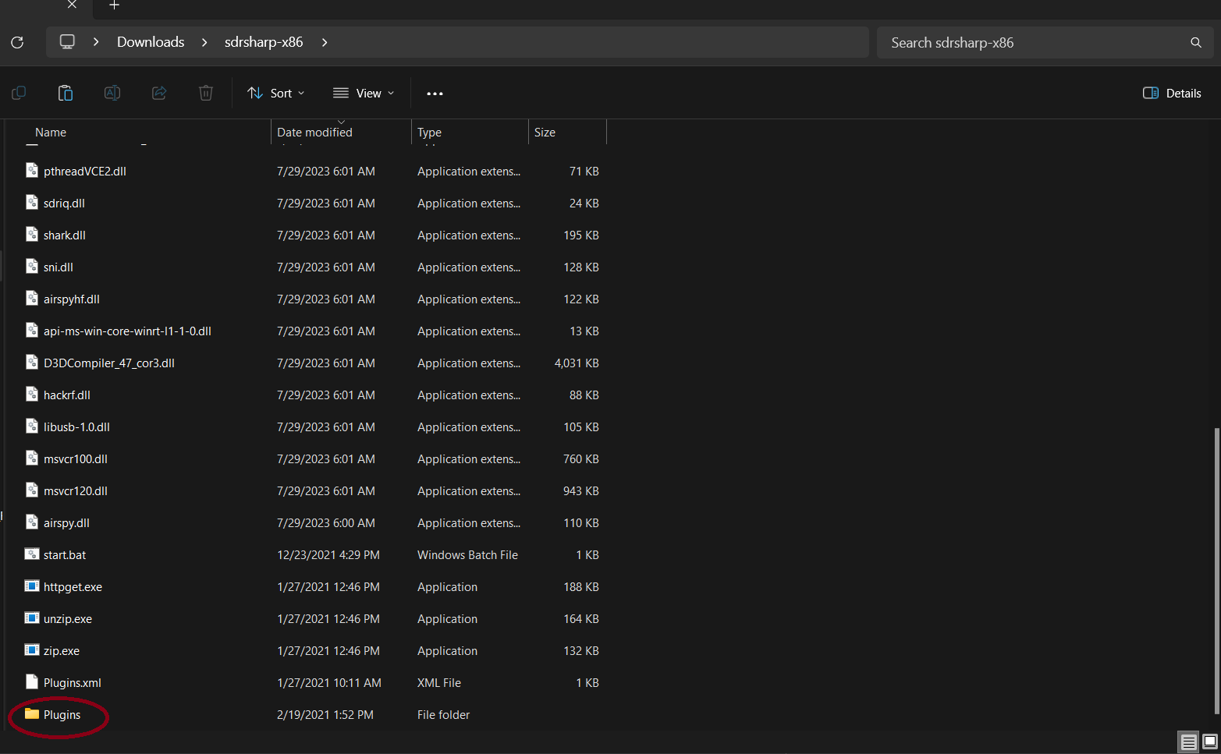

Open this file and paste in the three files you copied earlier.

1. Now, navigate back to the “sdrsharp-x86” folder and relaunch SDR Sharpe. Once it loads, click on the 3 bars in the top left (yellow circle in the image bellow). A drop down menu should have appeared. At the very bottom there should be a sub-menu that says “Plugins” (red circle in the image bellow). If you over over this sub-menu there should be one option that shows up that says RTL_433. If you see this option then you have successful installed the plugin, if not then double check the steps above.

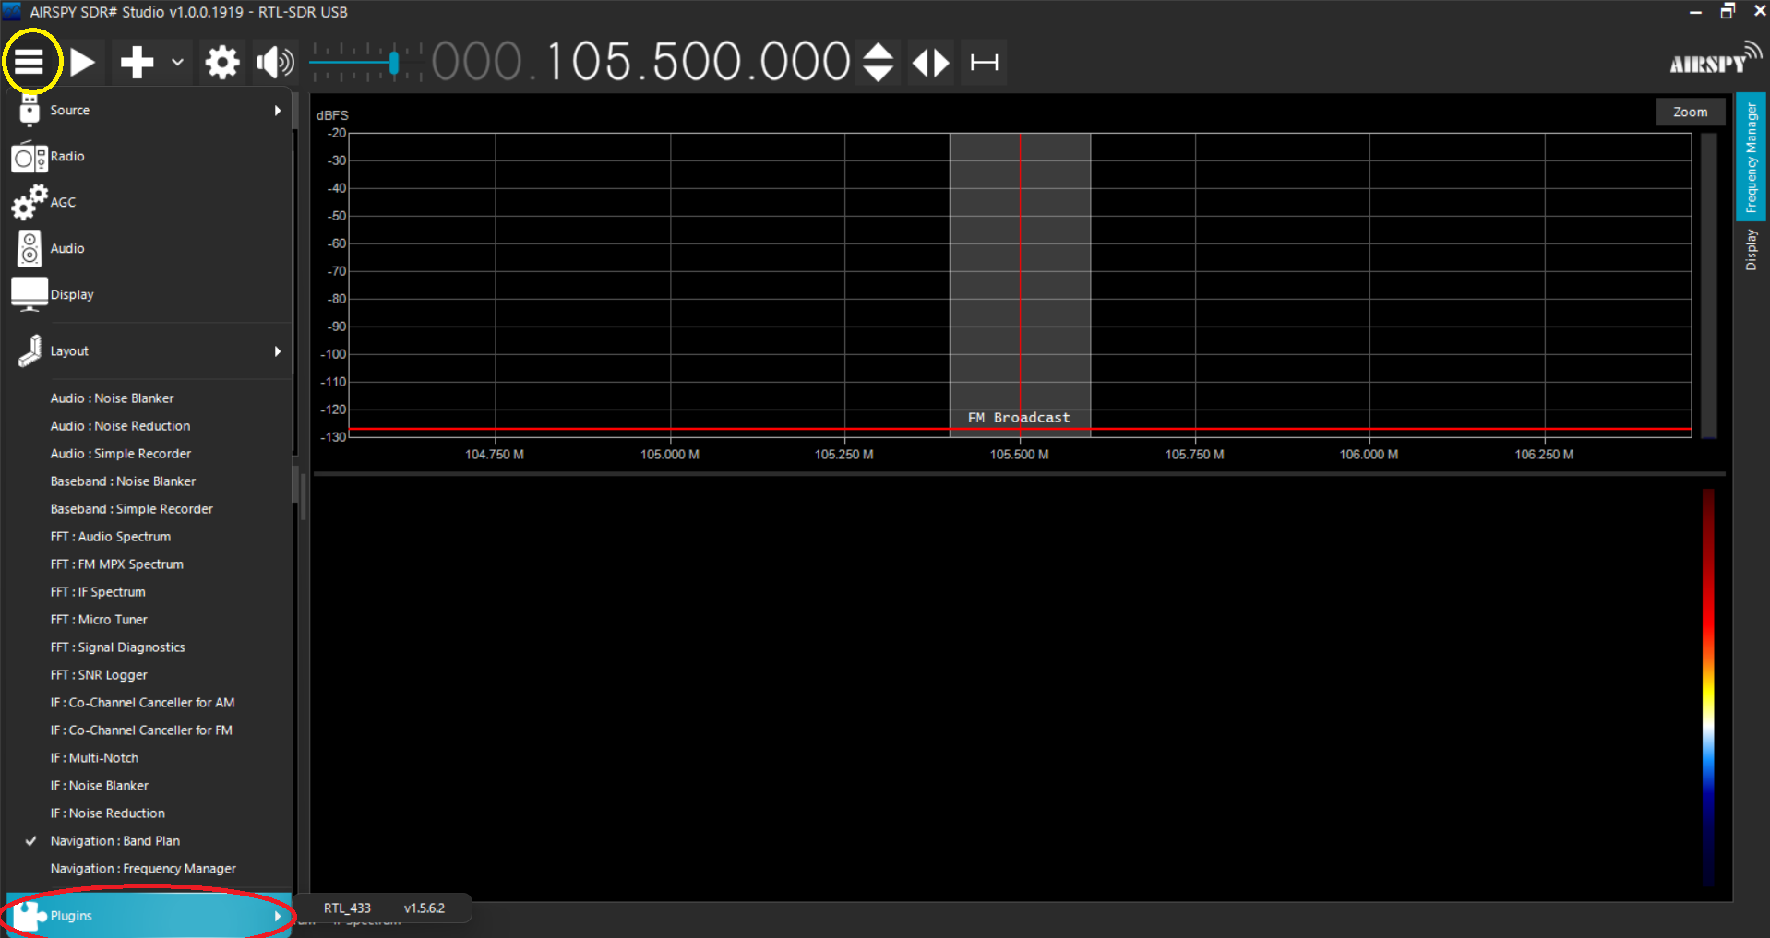

The software is now ready to be used.

**SDR Sharp:**

With the software now ready we can now explore SDR Sharp by using it in three different ways. To listen to an FM radio station, decode 433MHz traffic thanks to the plugin we installed, and listen to the NOAA Weather Radio.

1. **FM Radio**
   1. For this section of the lab we will be listen to an FM radio station. Now if this lab is being done after the GNU Radio Lab then this may seem familiar. Yes we are basically doing the same things but there are also some key differences as well. GNU Radio is fully customizable. We only explored a small part of what GNU Radio could do. SDR Sharp on the other hand is no where as customizable as GNU Radio. You can add a lot of functionality to SDR Sharp thanks to plugins but it does not come close to GNU Radio. So then you might be wondering why we are even exploring SDR Sharp and that is a good question. Do you need a rocket ship to drive the grocery store or will a pickup truck do the same job? GNU Radio is the rocket ship in this analogy, in that is so powerful it is overkill for “just going to the store”. SDR Sharp helps us in that its capable but doesn’t drown us in all the options GNU Radio has.
   2. So to start this section, open SDR Sharp. The “SDRSharp.exe” should be in the extracted folder from Setup step 3.
   3. Now we need to tell SDR Sharp what SDR to use in our system. As can be seen in the image bellow, open the 3 bar menu and the go to Source → Configure.
   4. 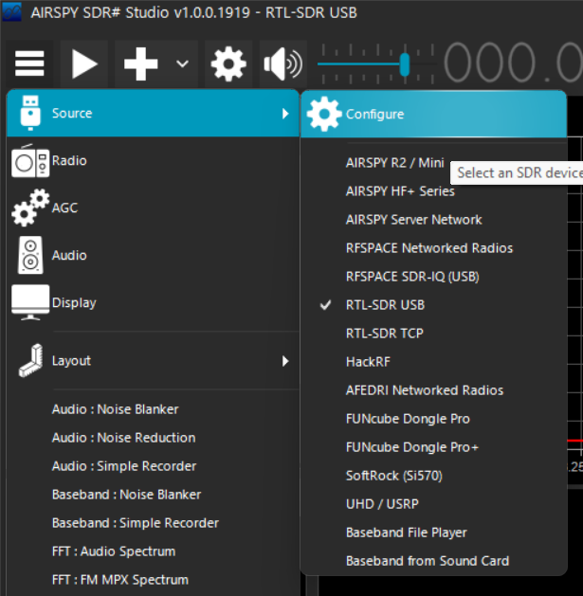A new menu should have been added to your display. You may have already had this menu already open but no all installs are the same. This menu should look like this.
   5. 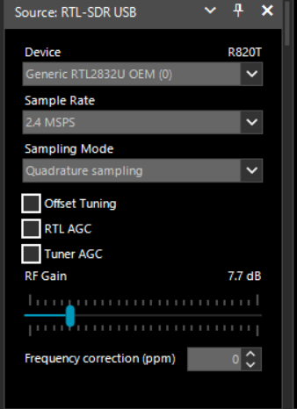The three things we care about in this menu are “Device”, “Sample Rate”, and “Gain”. For the device, there should only be one option in that drop down menu. If there are no option in that menu double check that the SDR is plugged in with its antenna. If it is plugged in, double check the install steps to make sure you ran the driver install program. For sample rate, it should have defaulted to 2.4 MSPS (Mega Samples Per Second). This is the value we wont, if 2.4 MSPS is not the one selected, selected it from the drop down menu. Finally the gain. We don’t need to change this for now but when we start listen to the different signals, you can raise and lower this value so you can boost faint signals. Remember gain is a balancing act, too much and everything becomes a “signal” even noise. But too little and the signal you might be looking for might be too faint to see or hear.
   6. Now go back to the 3 bar menu and click on the “Radio” button. A menu like the one below should have opened up if you didn’t have it already opened.
   7. 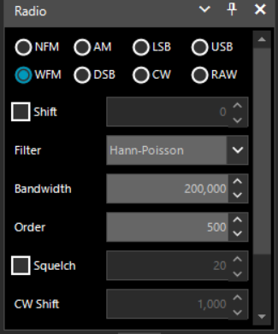Some of these option might seem familiar if you have done the GNU Radio Lab. For this section we want the WFM (Wideband Frequency Modulated). Bandwidth is a value we are going to be changing to make sure the radio stations we turn to fill up this bandwidth but not too much as we don’t want to pick up noise. Now its time to plug in an FM radio station you know is in you area, for me I will tune to 93.3. To do this, change the number in the top center of the program by clicking on the top or bottom half of each number to change it.

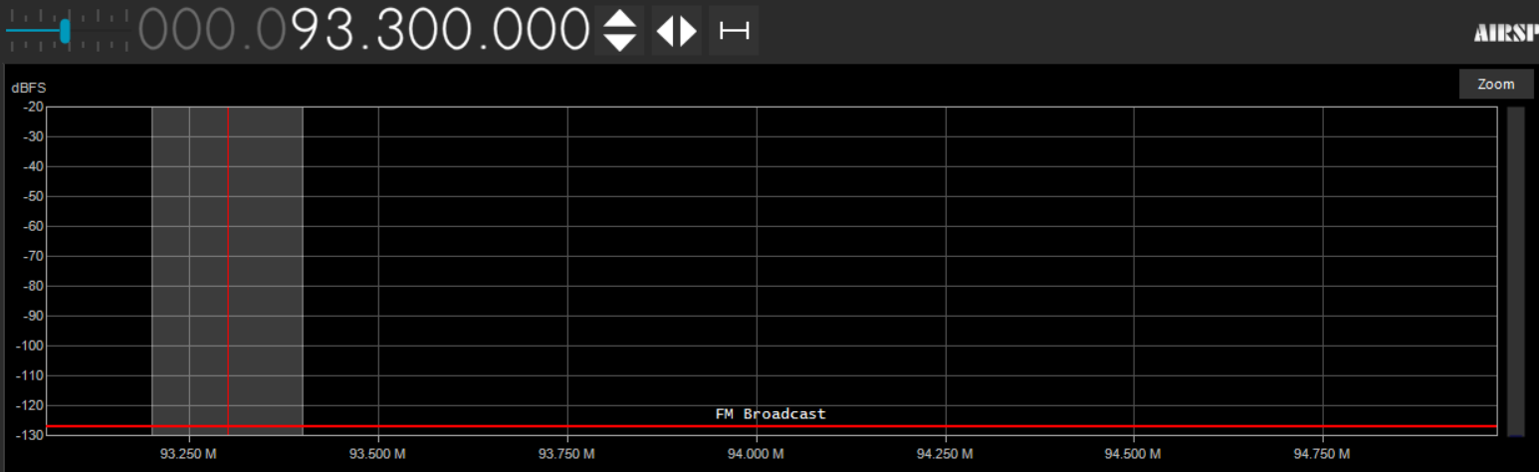Another cool thing to note at the bottom of that chart you can see SDR Sharp already knows this is the FM band and is telling us so. It also knows other common bands as well so after the lab feel free to explore the spectrum to find the other common bands.

* 1. Now it time to listen to the station you have tuned to. Hit the play button in the top left next to the 3 bar menu. Also remember to have your computer speakers on and the volume turned up enough for you to hear but not too loud please.
  2. Your should now start to hear the radio station you tuned too and you window should look similar to the image bellow. I have moved where SDR Sharp will show the frequency I am tuned too further to the right by dragging he X axis that has the frequency numbers.

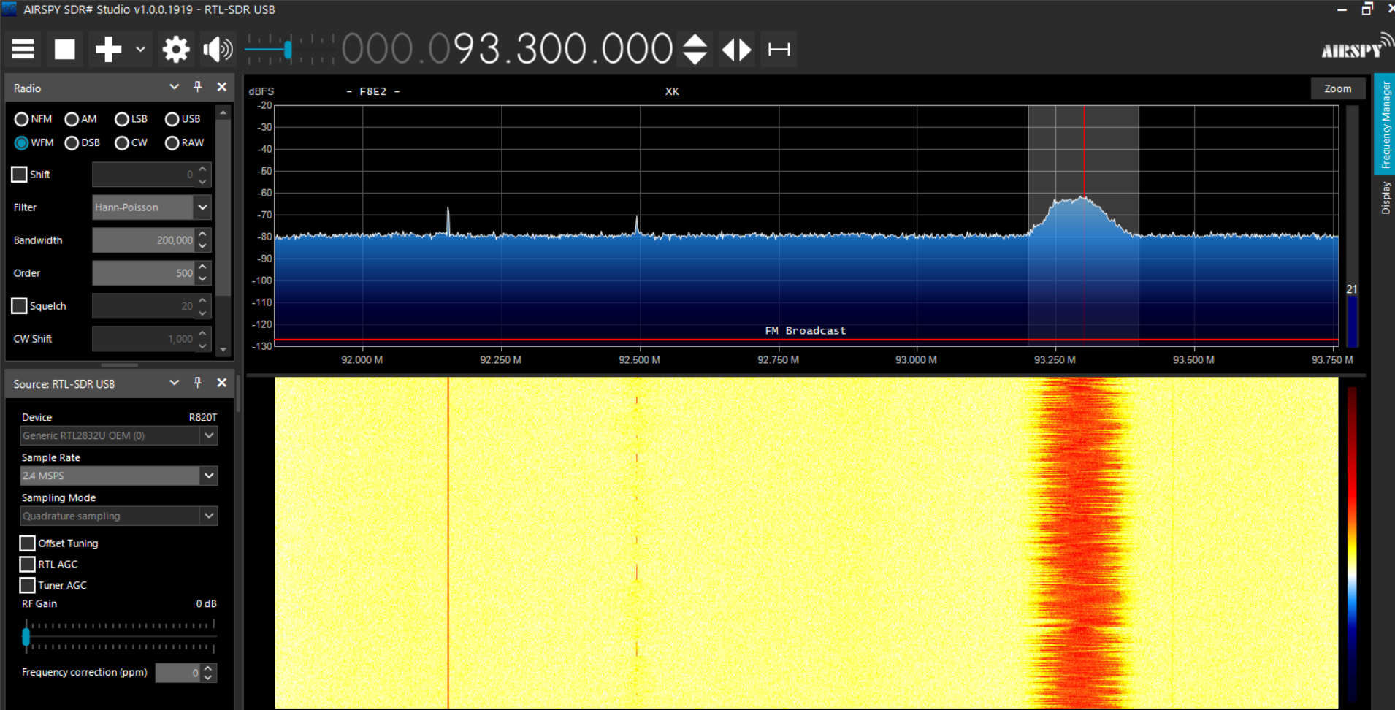

The red in the image shows the strength of the signal we are currently listening to. Under the frequency number there can be some numbers or letter that might appear. A lot of FM stations embed Identification information that, thanks to SDR Sharp, we can see. My problem is that I am getting something but its not a full message so lets try boosting the gain a bit and see if that helps.

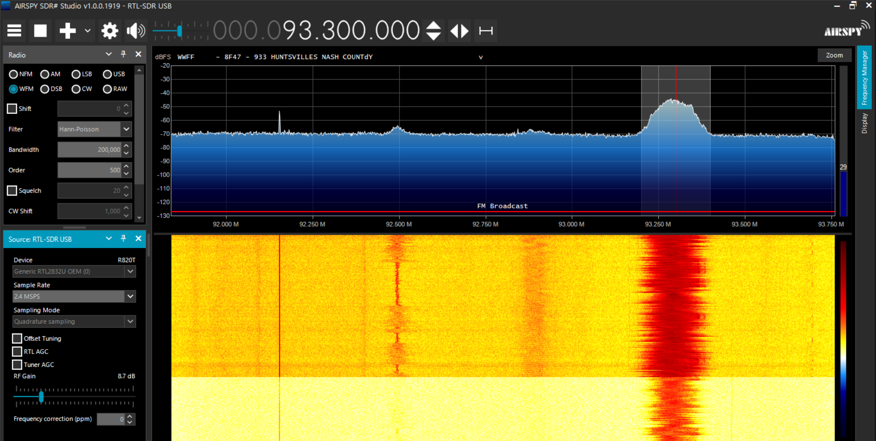And there we go. I got the full identification message. And there is also something new, well two things. I will go into detail about those in a moment but for right now. Play around with Bandwidth and gain to find what works for you and the stations around you. If you set you gain to high you will probably start to pickup a lot of static if your station is not very strong. The same thing goes for bandwidth, we want enough for the signal to fit within the light gray area in the top graph you see above. Too small and we don’t pick up part of the signal and the sound becomes distorted, too much and static starts to come through.

* 1. Now onto the two things I found when I boosted the gain. Remember, everything here on to the end of this section will only directly apply to where I am when picking up these stations but the observation made here will help you explore around you. In the image bellow take a look at the signal in the light blue box. In the bottom half of the screen that the yellow field suddenly turned more orange. This is when I boosted the gain. Before I boosted the gain, we could see the signal but it was not supper strong, now with the boosted gain we can indefinably see it. Now you might want to tune to it immediate and you can but you will not get any audio. See how the signal is a straight line with no “wave” to it? This means its a data stream in the FM spectrum and there is no audio to pickup there. But on the other hand look at the signal in the dark blue box. It has a “wave” to it, so there is a good change there is audio there. Also see how that before I boosted the gain, we couldn’t even see the signal.

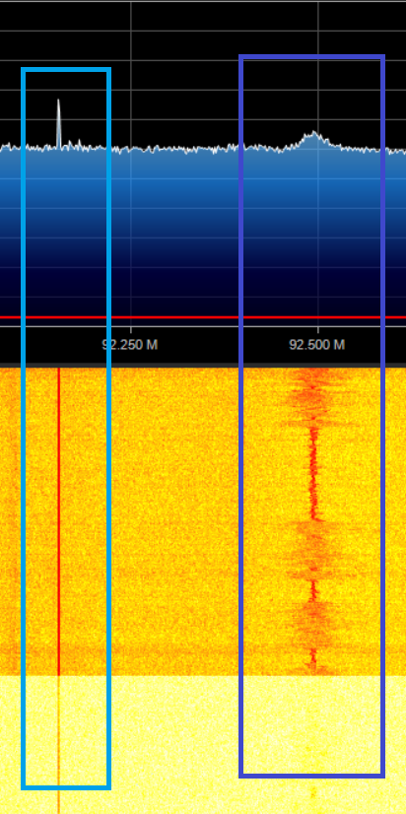

* 1. So I turned to the signal in the dark blue box but all I hear is static and maybe a little audio. Look at the bandwidth compared to the signal we are listening to, the bandwidth is too high so I am going to lower it.

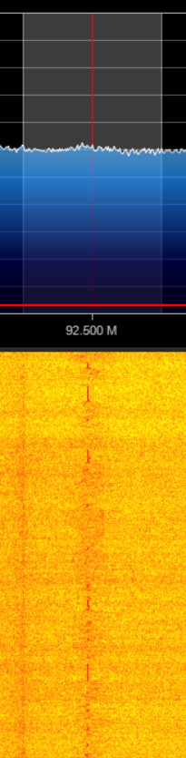

Me lowing it the bandwidth help limit the about of noise being pickup but it is still very staticy. This appears to be a very weak signal with were I am and the antenna I have pushing the limits of range of the station I have tuned too. So I have one last trick up my sleeve to try and clean up the signal. Audio noise suppression.

* 1. In the three bar menu I am going to select the item “Audio: Noise Reduction”. It will open a new menu that looks like this.

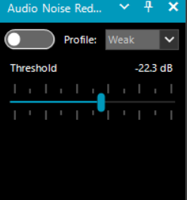There are only three controls in this menu, the on and off slider, the profile to use for the noise reducer, and then the strength slider on how strong the reducer should be. I have found the “Weak” profile to be the most consistent when it comes to getting noise out of the signal but play around with these settings on the weak signals in you area. Now after I turn on the filter and turn some of the settings I can now make out the words being spoken in the signal but its till very distorted. There is not much more I can do to improve the signal beyond this other than get closer to the signal or get a bigger antenna.

1. **433MHz**

Teacher note: please start the 433HMz transmission that was detailed in your supplemental notes

* 1. Now we will explore to use of plugins in SDR Sharp by exploring the 433MHz band. This band is commonly used by low powered devices to communicate information. These devices range quite widely from tire pressure sensors, to fan controls, to security systems.
  2. First we need to open the plugin menu we installed earlier. Click on the three bar menu in the top left of SDR Sharp and navigate to Plugin → RTL_433. The menu in the image bellow should have appeared.
  3. 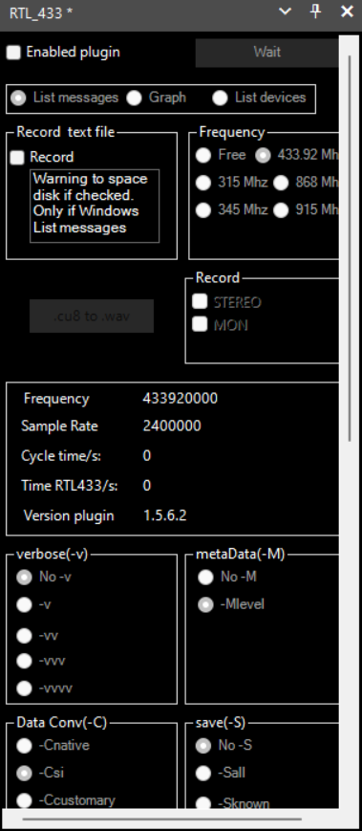There are a lot of option in this menu but all we care about are the “Enabled plugin” check box and the “Frequency” section. While the plugin is named 433 it can decode messages in more than just the 433MHz band but in this lab we will only forces on 433MHz. So enable the plugin my check marking the “Enabled plugin” box and selecting “433.92 Mhz” in the Frequency section.
  4. We then need to tune the SDR to 433.92 MHz. To change the frequency, find the number in the top center of the program and clickon the top or bottom half of each number to change it. It should look like this when you are done.

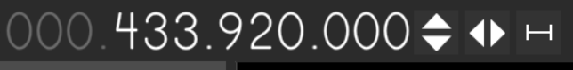

* 1. Now hit the play button in the top left of SDR Sharp to began capturing data.
  2. With the data now being captured, go back the them RTL_433 menu and hit the “Start” button. Two new windows should have popup ed. One will be just a blank window, do not close this window as that window is running the plugin. The other window, that might be hidden by SDR Sharp so if it is just minimize SDR Sharp for the moment, will look similar to this.

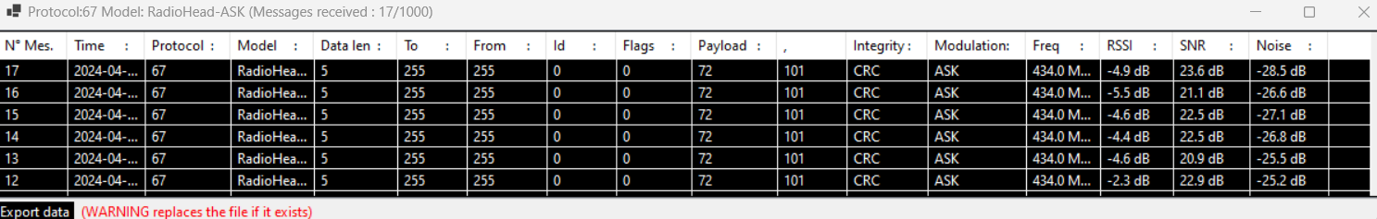This window may contain several things or just the device you see in the image above. This window decodes the messages it hears on the 433MHz band and lists them here. It tells you when it heard it, what protocol its using with in the above image being one called RadioHead-ASK, how long data section of that message was, and other important

* 1. Explore the different messages coming in.
  2. Extra: Back in the RTL_433 section find this section.

In action F, that list that was generated was due to this setting being in “List messages”. Explore what the other two options do.

1. **NOAA Weather Radio (United States only)**
   1. For this final section we will listen to the NOAA Weather Radio broadcast. This is a radio station that the Nation Weather Service maintains across most of the United States. Its is both a data channel that sends out weather bulletins (ever wonder why your weather radios all of a sudden go off even if you are not actively listening to the broad cast? This is why) and an audio portion that has the bulletin spoken aloud. The data stream wakes up all weather radios that can receive the broadcast and decodes the bulletin to display on your weather radio. It then turns of the speaker of your weather radio so the spoken bulletin can be heard. This is a very light over view of the NOAA Weather Radio system but enough for use to work with. If you want to know more please visit <https://www.weather.gov/nwr/>.
   2. For this lab will will only listen the audio portion of the broadcast. While there are no sever storms in the area of the writing of this lab and I hope there are not in the area this lab is being administered in as well, NOAA Weather Radio constantly broadcasts the forecast for its assigned region. First we need to find the frequency the station is on. NOAA Weather Radio uses 7 different frequencies between 162.4 MHz and 162.55 MHz. These frequencies are specially reserved by the FCC (Federal Communications Commission, the people who control who gets to use what frequencies in the United States) for the Nation Weather Service to have NOAA Weather Radio on. No one else is allowed to use these frequencies in the United States. To find the frequency of your local NOAA Weather Radio tower go to <https://www.weather.gov/nwr/station_search> and type in your location. In the bottom right of the map that pops up there will be a section named “Frequency”. Write that down as that is what we will be tuning too. For me, my frequencies is 162.4MHZ
   3. Back in SDR Sharp dial in the frequency of your NOAA Weather Radio station you found in the last step. In the “Radio” menu make sure the “WFM” is selected. Once set hit the play button.
   4. You should now be hearing NOAA Weather Radio. The sound might be very staticy. To fix this try reducing the Bandwidth in the “Radio” menu to 100000. NOAA Weather Radio has a significantly narrower bandwidth compared to FM radio stations so the value we used in

**Conclusion:**

In this lab we explored another tool that us used to explore the radio spectrum. We listened to FM radio stations, decode some 433MHz messages, and listened in on the NOAA Weather Radio. Through this lab you will have been shown that there are several uses for SDR Sharp, and thanks to plugins, there are even more things SDR Sharp can do. Take what you have learned in this lab and in the lectures for this lab and explore the radio spectrum and all the signals that are invisibly all round us.